Training and Development Needs Assessment

at

Pu Luong Nature Reserve,
Thanh Hoa province,
north-central Vietnam

Fauna and Flora International Vietnam Programme

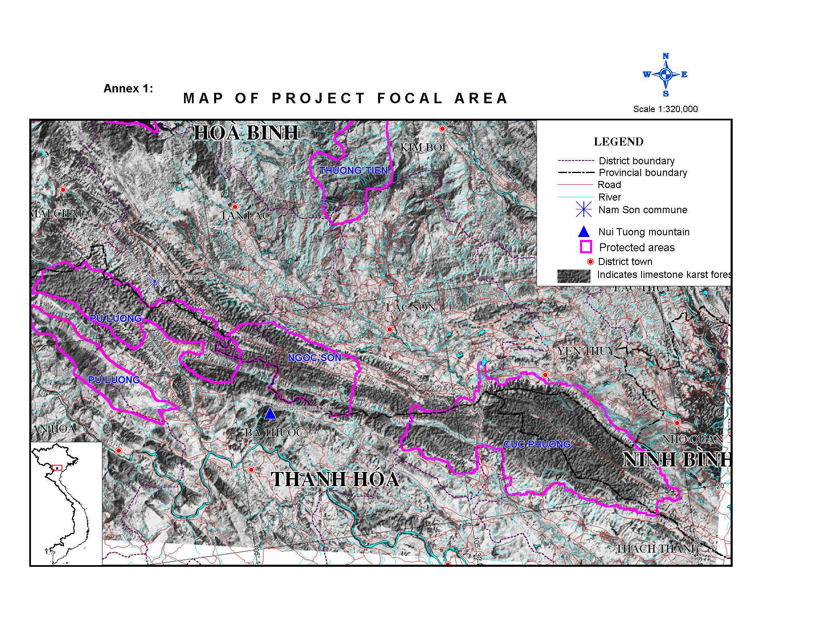

The strategy for the assessment at Pu Luong comprised four stages:

- Initial scoping and data collection;

- Participatory staff assessment;

- Review, feedback and finalization;

- Formulation of training and staff development strategy.

Stage One: Initial scoping and data collection

Step 1: Identify the obligations and objectives of the PLNR management board.

Step 2: Identify the jobs (or posts) that exist with PLNR and the structure of these.

Step 3: Compile job descriptions for each member of staff employed by the PLNR, which includes a list of duties and responsibilities required by each job.

Step 4: Collect information regarding the existing skills of each person employed by the PLNR.

Step 5: Compile the above information into a single report

Stage Two: Participatory staff assessment

Three tools were used.

1. ‘Duties and Skills’ Analysis

Objective: To identify the skills required for existing duties and tasks performed by FPD staff, rank these in order of training need and obtain practical suggestions for appropriate training activities.

Activity: The table below is filled out by FPD staff with the aid of facilitators.

Duties & Responsibiltities (i) | Skills (ii) | Training Need (iii) | Suggestions (iv)

Method:

- List the duties and responsibilities carried out by FPD staff
- List the most important skills needed to carry out each duty
(at this point, put the duties and analysis aside and begin the problem analysis)
- Number the skills in order of importance, the most important = 1.
- Starting with the most important skills, list practical suggestions for how training should be carried out.

2. Problem Analysis

Objective: To identify recurrent problems faced by staff in their work and obtain solutions to these, with a special emphasis on skills development.

Activity: The table below is filled out by FPD staff with the aid of facilitators.

Problems (i) | Causes (ii) | Solutions (iii) | Skills Needed (iv)

Method:

- Identify common problems staff encounter in their work
- Identify the major causes of these problems
- Assist the group to identify possible solutions
- Assist the group to idenitfy skills which would help promote these solutions
- Copy new skills identified to column three of the duties and skills analysis table and carry out the remaining steps (iii & iv).

3. Competence standard Checklists

S = Are you happy with your skill in this area ? (√ = Yes, X = No)

R = How important is this skill for your job ? (X = Not important; 1 = Low , 2 = Medium, 3 = High)
T = How would you rate your need for training in this skill ? (X = None; 1 = Low , 2 = Medium, 3 = High)

Financial and Resources Management (42-43)
 | General skills | Knowledge needed | S | R | T
2.1 | Manage and present evidence of expenditure | Basic financial record keeping
3.3 | Manage equipment, supplies and property | Stock, inventory and maintenance systems

Human Resources Management (44-45)
 | General skills | Knowledge needed | S | R | T
3.1 | Brief, supervise and motivate individuals and teams | Technical knowledge and team building skills  Mission, objectives and staffing structure of the PLNR  Organisational policies and procedures  Negotiation and conflict resolution techniques
3.2 | Monitor and evaluate workers perfomance and provide feedback
3.5 | Initiate disciplinary procedures and grievance procedures
3.7 | Resolve workplace conflicts
Communicaton (47-48)
 | General skills | Knowledge needed | S | R | T
2.1 | Make effective oral presentations | Simple presentation techniques  Report writing formats
2.2 | Prepare written accounts of work activities | Simple presentation techniques  Report writing formats
3.1 | Organise and faciliate meetings | Facilitation techniques  Comprehensive knowledge of the protected area
3.5 | Represent the protected area at public events
4.1 | Negotiate agreements and resolve disputes and conflicts | Conflict resolution and negotiation techniques  Knowledge of legislation and technical issues involved
Field Craft (52-54)
 | General skills | Knowledge needed | S | R | T
1.1 | Follow good evironmental practice in the field | Effects of impacts of bad practice on the environment  Standard first aid and CPR techniques
1.3 | Provide CPR and first aid in the field using accepted techniques
2.3 | Field navigation and orientation | Principles of navigation and orientation  Knowledge of local terrain and topography  Accident and emergency procedures
3.1 | Plan and organise logistics for field-trips, surveys and patrols
3.2 | Conduct search and rescue operations in the field
Natural Resource Assessment (55-58)
 | General skills | Knowledge needed | S | R | T
1.1 | Recognise main habitats and key species | Local flora and fauna, including key species  Findamentals of scientific approach
1.3 | Accurately record and report field observations

Stage Three: Review, feedback and finalization

 | Area/ Skill | Ranking by  Reserve Staff | Ranking by  Reserve  Directorate | Ranking by Hoa  Binh FPD staff
 | Communication skills
1 | English language skills | * | High | High
2 | Report writing skills | High | Medium | High
3 | Presentation and awareness raising skills | Very High | High | Medium
4 | Negotiating community conservation and  management agreements | High | * | *
 | Socio-economic survey skills
5 | Natural resource-use assessment | High | Low | High
6 | Planning and implementing socio-  economic surveys. | High | Low | *
 | Management and capacity-building skills
7 | Natural resource management, planning  and organization | Medium | High | Medium
8 | Facilitating and coordinating capacity-  building activities | High | * | *
9 | Agro-forestry methodologies | High | Medium | Medium
10 | Participatory methods | Medium | Low | *
11 | Leadership skills | Medium | Low | *
12 | Forest fire prevention skills | Medium | Low | *
 | Biodiversity skills
13 | Biodiversity conservation, protected  area management and cave management | Medium | High | High
14 | Biodiversity survey and assessment skills  (including cave management and  specimen preparation skills) | High | High | (see 13)
15 | Wildlife rescue (including rescue,  short-term care and release techniques) | * | High | *
 | Field craft
16 | First aid | High | Medium | Low
17 | Field navigation and map-making  using GPS | High | High | High
18 | Camp building skills | High | Medium | *
19 | Use of field survey equipment | High | High | High
20 | Guiding eco-tourists | Medium | Medium | Low
21 | Cadastral Skills | Medium | Low | *
 | Administrative skills
22 | Computer literacy | Medium | High | High
23 | Proposal writing | * | High | *
24 | Digital camera use | * | High | *
 | Enforcement skills
25 | Preparation formal reports of offences and cases for court; issuing formal warnings and guidance | High | Low | Low
26 | Self-defence skills | High | Low | *
27 | Developing and managing informant networks | High | Low | *
28 | Planning and implementing patrol and enforcement activities | High | Low | Low

Stage Four: Formulation of training and staff development strategy.

Area/ Skill | Training Methods | Program | Notes
Communication skills
English language skills | - Training Course  - Interactions with International Staff | English Teaching to counterparts will be given by the Field Operations Assistant; under supervision of Field Operations Manager | This programme will be started in June, and will comprise a long-term training programme.
Report writing skills | - Mentoring  - Short Training Course | Mentoring by Senior Staff (Mr Cai) will be undertaken.  Short training course by FPD Than Hoa if necessary. | If this is deemed a priority by FPD it must be conducted by Senior FPD Management since reports are specific to demands of FPD.  Scientific and survey reports are dealt with under Biodiversity Skills)
Presentation and awareness raising skills | - Mentoring  - Site visits  - On-the-job Training  - Attachment  - In-house training courses | Reserve Directorate has expressed desire that at least nine staff is involved with Project activities in this field.  A site visit should be undertaken to a number of reserves to see their awareness programme, possibilities Cuc Phuong National Park.  The possibility of attachment of two Rangers to the Cuc Phuong Conservation Awareness Programme should be investigated.  In house capacity will be used to develop and undertake training in community awareness programmes. | This is identified as a key weakness in the existing skills of the Reserve, and FPD in general. This has been deemed a high priority by FPD. It rather depends upon the recruitment of a competent Awareness Officer who should have experience in modern awareness raising and presentation skills.
Negotiating community conservation and management agreements. | - On-the-job training  - Site visits | Forest Rangers will be involved in the negotiation of community agreements with the Project.  Project Staff, community members and Reserve staff will attend study tour to Ba Be National Park. | Regarded as low priority by Reserve Directorate.
Socio-economic survey skills
Natural resource-use assessment | - On-the-job training  - Site visits
Planning and implementing socio-economic surveys | - On-the-job training  - Site visits
Management and capacity-building skills
Natural resource management, planning and organization | - Study Tour  - Workshop | Study tour to look at biodiversity conservation an natural resource management  Study tour to look at conservation and development linkages (Ba Be National Park)  Director to attend ARCBC Karst workshop | Consider human resource management training course.
Facilitating and coordinating capacity-building activities | - Mentoring  - On-the- job training
Agro-forestry methodologies | - Study Tour  - Project Activities  - Case-studies | Attend Ba Be study tour  Through project activities and participatory technology and development with local villages | Further visit to GTZ Son Da project
Participatory methods | - Study Tour  - Project Activities  - Case-studies | Attend Ba Be study tour  Through project activities and participatory technology and development with local villages
Forest fire prevention skills |  | See Awareness Raising | Regarded as low priority by Directorate, skill development for this activity can be developed through improved communication skills.  Technical input should come from FPD.
Biodiversity skills
Biodiversity conservation, protected area management and cave management | - Workshop on cave management / ecotourism  - Study Tour  - ARCBC course on karst conservation  - Reference materials | Study tour to examine biodiversity conservation and protected area management for FPD staff  Workshop to examine managing caves and impact of ecotourism | Masters degree should be encouraged for Reserve Director.
Biodiversity survey and assessment skills  (Including cave survey and specimen preparation skills) | - On-the-job Training  - Capacity building / Mentoring by Project Staff and Consultant  - Linkages with National Consultants and Universities. | Staff will be trained in range of activities including:  Design, analysis and reporting of survey results  Habitat and Landscape Monitoring  Species conservation  Primate and Delacour Langur survey  Basic Zoological and Botanical Survey techniques | This will be conducted in conjunction with the biodiversity survey and monitoring activities. Three Reserve staff have been identified as requiring capacity in biodiversity survey under new Reserve structure. Note, other Rangers will be trained in basic techniques; emphasis will be on straightforward techniques requiring limited capacity.  Factor training and capacity building into TOR of consultants.
Wildlife rescue (including rescue, short-term care and release techniques)  Identified lack of knowledge:  Introduction of Species | - Secondment  - Workshop / Cuc Phuong National park | Secondment to EPRC in Cuc Phuong National Park | Directorate regarded this as high priority. A recent study to EPRC explained the problems of developing this capacity.  Release of non-native species and those from other areas to Pu Luong should not be encouraged.  Project regard that if release of non-native species to Phu Luong is to be started then a workshop / study tour should be undertaken for Provincial and Reserve level staff.
Field craft
First aid | - Training Course | Short training course for Ranger Staff
Field navigation and map-making using GPS | - Training Course  - On-the-job training | Short training course to be undertaken by Cuc Phuong National Park staff
Camp building skills | - Training Course  - On-the-job training | Short training course to be undertaken by Cuc Phuong National Park staff
Use of field survey equipment | - On-the-job training | Working with appropriate consultants
Ecotourism | - Workshop  - Study Tour | Attend community based ecotourism workshop  Develop skills in guiding  See ecotourism at another location (in conjunction with villages)  Cave management / ecotourism workshop  Site visits to tourism department at Cuc Phuong National Park
Cadastral Skills |  |  | Not necessary
Administrative skills
Computer literacy | - FPD mentoring | Suggest not really feasible option for the Project, despite being ranked highly by Hoa Binh and PLNR. | Directorate expressed need for all staff to be trained in computers; though there only is one Reserve computer.  Reserve also suggested that staff should be trained in all computer programs, offering no clear rationale behind training in such programs. This is clearly unfeasible and unrealistic.  Staff at headquarters may benefit in a short training course, but this knowledge should be passed on to other visiting Rangers.
Proposal writing | - Mentoring | Develop proposals for education and scientific survey in conjunction with project staff | Develop at least two proposals in conjunction with project staff.  Exposure to other projects and NGO’s will be advantageous.  Investigate courses run by NGO centre.
Digital camera use | - Training | Short training in conjunction with landscape monitoring
Enforcement skills
Preparation formal reports of offences and cases for court; issuing formal warnings and guidance | - Mentoring | Mentoring by Senior Reserve Staff
Self-defence skills |  |  | Training already undertaken by some Reserve staff
Developing and managing informant networks | - Training Course | Short training course | Not identified as high priority by Reserve Directorate
Planning and implementing patrol and enforcement activities, legislation | - Training Course | Short training course | Not identified as high priority by Reserve Directorate

